 TROVARA FARM CREDITS
CUSTOMER ACCOUNT INVITATION
Subject: Your 2,000 Trovara Farm Credits are ready
Preheader: Activate your account and unlock your personal referral link.
Hi {{first_name}},
Because you completed our survey and asked Trovara Farm to stay in touch, you're eligible for Trovara Farm Credits.
Claim your Trovara Farm account to receive 2,000 Trovara Farm Credits and unlock your personal referral link.
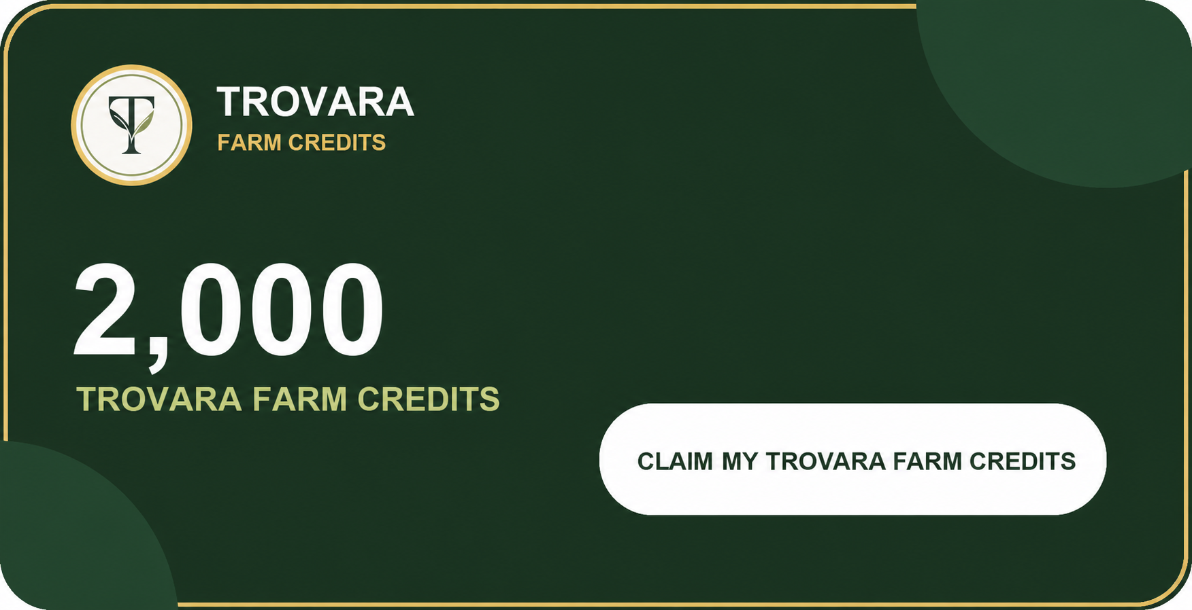
{{activation_url}}
SHARE THE GOOD FOOD
Once activated, share your referral link so friends who complete the survey can unlock their own 2,000 Trovara Farm Credits.
Full referral details and programme terms will be shown during account activation.
P.S. Your 1,000 referral Trovara Farm Credits become available after your referred friend's first eligible Trovara Farm purchase passes its refund period without a refund.
P.P.S. Trovara Farm Credits can only be used to buy eligible products sold by Trovara Farm. They are promotional credits, not cash.
Instagram · TikTok · Facebook · LinkedIn
From all of us at Trovara Farm
Food you can trust, from a farm built for tomorrow.
You are receiving this because you asked Trovara Farm to contact you after completing our survey. Privacy · Unsubscribe

